A CI/CD **pipeline** is a series of steps that must be performed in order to deliver a new version of software. Continuous integration/continuous delivery

What is CI CT CD pipeline?

[[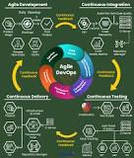](https://www.google.com/search?q=What+is+CI+CT+CD+pipeline?&rlz=1C1CHZL_enIN777IN777&sxsrf=AOaemvI55pMY_2t8rEuldSOKC21xBiYE8g:1639719163621&tbm=isch&source=iu&ictx=1&fir=IyG_x7gCGfc8EM%2CcmCBUf9fR-tKhM%2C_&vet=1&usg=AI4_-kTRK14VjiUj9KSDHUY7RzRfJa2Bzg&sa=X&ved=2ahUKEwjepZ3yjer0AhUSS2wGHQ7LBq4Q9QF6BAgYEAE#imgrc=IyG_x7gCGfc8EM)](https://www.google.com/search?q=What+is+CI+CT+CD+pipeline?&rlz=1C1CHZL_enIN777IN777&sxsrf=AOaemvI55pMY_2t8rEuldSOKC21xBiYE8g:1639719163621&tbm=isch&source=iu&ictx=1&fir=IyG_x7gCGfc8EM%252CcmCBUf9fR-tKhM%252C_&vet=1&usg=AI4_-kTRK14VjiUj9KSDHUY7RzRfJa2Bzg&sa=X&ved=2ahUKEwjepZ3yjer0AhUSS2wGHQ7LBq4Q9QF6BAgYEAE" \l "imgrc=IyG_x7gCGfc8EM)

Continuous Integration (CI), Continuous Testing (CT), and Continuous Delivery (CD) are considered to be the key metrics **to measure successful** DevOps practice. ...

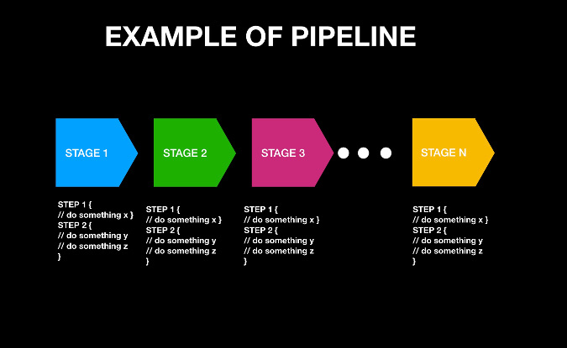

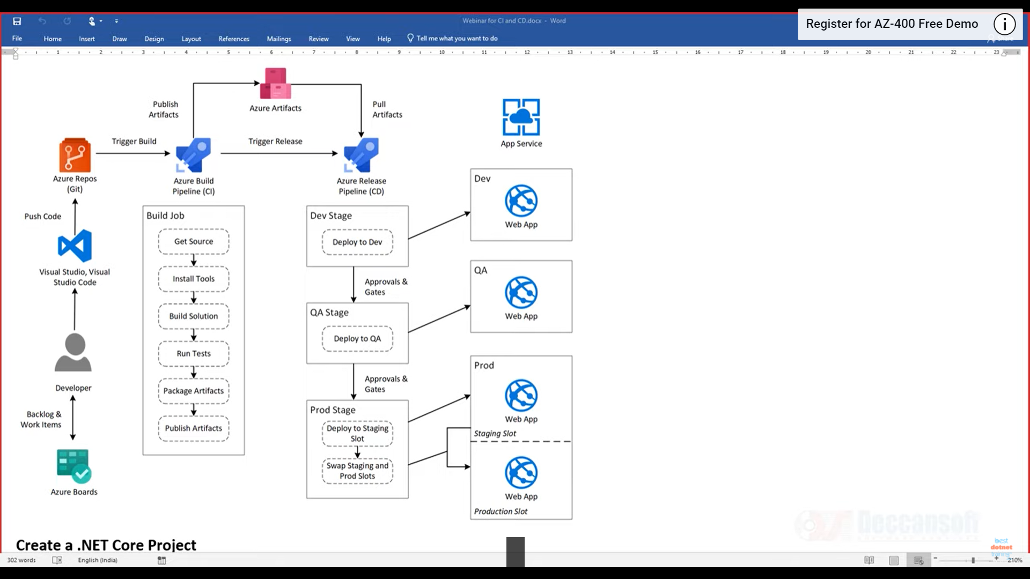

We will see complete lifecycle of how an application goes from developer machine into production machine

Different stages it will go through

Start from developer

I as developer create a project (any stack)

We will create CI pipeline. A developer after creating project has to build and test it locally on system (IISEXpress)

There could be multiple developers working on that project. That is why we need some Version Source control

Push ut code to Azure Repo

Go to Azure Devops , you will get source code

For all this Azure Devops provides us agent machine

E:\>dotnet new sln -o HelloApp

E:\>cd HelloApp

E:\HelloApp>dotnet new mvc --name HelloApp.Web

E:\HelloApp>dotnet sln HelloApp.sln add HelloApp.Web\HelloApp.Web.csproj

E:\HelloApp>dir

E:\HelloApp>dotnet restore

E:\HelloApp>dotnet build --no-restore --configuration release

E:\HelloApp>dotnet publish --no-build --configuration release

E:\HelloApp>dotnet E:\HelloApp\HelloApp.Web\bin\Release\net5.0\HelloApp.Web.dll

E:\HelloApp>cd HelloApp.Web

E:\HelloApp\HelloApp.Web>dotnet E:\HelloApp\HelloApp.Web\bin\Release\net5.0\HelloApp.Web.dll

E:\HelloApp\HelloApp.Web>cd ..

**Push it to Azure Repo**

E:\HelloApp>git init

Initialized empty Git repository in E:/HelloApp/.git/

E:\HelloApp>git add .

E:\HelloApp>git commit -m "Initial Code"

E:\HelloApp>git remote add origin https://DevOpsAzureDemobyAnamika@dev.azure.com/DevOpsAzureDemobyAnamika/HelloWorldApp/\_git/HelloWorldApp

E:\HelloApp>git push -u origin master

**Do some changes**

E:\HelloApp>code .

E:\HelloApp>git add .

E:\HelloApp>git commit -m "Added"

E:\HelloApp>git push -u origin master